**Python Course Capstone Group Project**

**IS 6495 Summer 2023**

**Topic:**

**Recipe Creator and Manager**

**Presented By:**

Group 14

**Prepared By:**

JADE GOSAR

OKECHUKWU AGOMUO

MELANIEANTHONY VADAKKEPEEDIKA

**Table of Content**

Pages

Executive Summary 3

Database Design – ERD 4

Class Diagram – Inheritance 4

Requirements Review 5-6

References 6

**Executive Summary**

For the Summer 2023 IS 6495 Python Capstone Project, we chose to work on the Recipe Creator and Manager because of its importance to users and the convenience and flexibility it provides for organizing and accessing their favorite recipes. The first thing we thought of, was where the recipe, ingredients and user data will be stored. So we started by designing a relational database schema (using SQLite) that will store data about these three entities using three different tables/relations. We then wrote a python script that read the data from a flat csv file where they initially existed, and populated the database tables. We proceeded with implementing the CRUD functionality by defining functions that allow users to perform each CRUD operation like create, read, update, and delete data from the database.

In this project, we implemented Object-Oriented Programming (OOP) by creating classes to encapsulate functionality related to recipes, ingredients, and user data, and also, to easily organize and manage our code. Three classes were defined to represent three entities: Recipe, Ingredients, and Users. Inheritance was also used with the classes. We also incorporated critical thinking and addressed several ethical considerations to ensure security and privacy of user data, being fully aware of the importance of ethics when handling user data. Some of the measures we took to incorporate ethics include: user-friendly interface - to ensure efficient interaction with the application, error handling - to gracefully handle potential exceptions during database operations or user inputs, and safeguards to protect user intentions during user inputs.

The project was painstakingly executed to address and accomplish all the requirements of the application as seen in the requirements review section.

**Database Design – ERD**

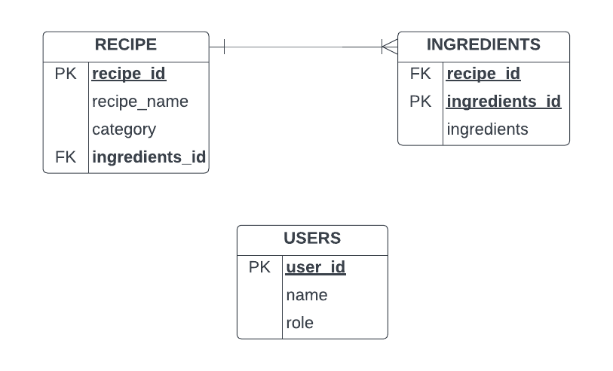

**Class Diagram – Inheritance**

**DBbase**

**Users(DBbase)**

**Recipe(DBbase)**

**Ingredients(Recipe)**

**Requirements Review**

|  |  |  |  |
| --- | --- | --- | --- |
| S/NO | REQUIREMENTS | IMPLEMENTATION | STATUS |
| 1 | Data should be migrated from a flat file (csv) into a relational Database for efficiency and security | Python script was used to open a CSV file, parse the recipe, ingredients and user data and used to populate the database tables | DONE |
| 2 | Users should be able to interact with the system | The application’s user interface enables users to interact with the system | DONE |
| 3 | Data should be well populated to enable the system to function properly | Database was adequately populated with each table having 36 rows. | DONE |
| 4 | Users should be able to add, fetch, modify, delete recipe and ingredients related information | Functions defined for each CRUD operation enable users to Create, Read, Update, Delete data from the database | DONE |
| 5 | Code should be reproducible and comprehensible | Code is properly documented with comments that explain the function of each code block | DONE |
| 6 | User data should be private and secured | Ethics was incorporation at a high level in this project to ensure privacy and security of user data. | DONE |
| 7 | System should efficiently handle exceptions and appropriately guide users | Error Handling is embedded in the entire program to gracefully handle potential exceptions and provide informative error messages to guide users | DONE |
| 8 | At least 2 classes should be defined to represent entities in the program | Three classes were defined to represent three entities: Recipe, Ingredients, and Users. Ingredients class inherits attributes from Recipe. | DONE |
| 9 | Code should be functional and run without errors | Code has been tested multiple times to ensure that the entire program is error free | DONE |

**References**

* <https://hoteltechreport.com/news/recipe-management-software>
* <https://www.techtarget.com/searchapparchitecture/definition/object-oriented-programming-OOP?Offer=abt_pubpro_AI-Insider>
* <https://www.prepbytes.com/blog/python/crud-operations-in-python/>
* <https://www.isaca.org/resources/isaca-journal/issues/2016/volume-6/an-ethical-approach-to-data-privacy-protection>
* <https://www.tpximpact.com/knowledge-hub/insights/ethical-data-collection/>
* <https://docs.swift.org/swift-book/documentation/the-swift-programming-language/errorhandling/>